Installing Appium test environment for Android Applications (Windows)

Contents

Introduction 2

Install Java JDK 2

Install Android Studio SDK 2

Install Emulator 3

Create Emulator 3

Install Ruby 5

Install Cucumber 5

Install Appium 5

Environmental Variables 6

# Introduction

This document will guide you through the set of steps required to complete the environmental installations necessary to execute a Ruby test script against an Android Studio mobile application.

Its intention is to assume nothing of any pre-requisite installations, however it is expected that the user of this guide will have a working APK of an Android Studio application complemented with at least one Ruby test script.

The following list is a summary of the software technologies that will be required to install the environment:-

* Java SDK
* Android Studio SDK
* Ruby
* Cucumber
* Appium

# Install Java JDK

To check the (latest) version of Java SDK is installed:-

* Open the Command Prompt
* Type java –version

At the time of writing the version installed is: build 1.8.0_60-b27. If this version or later is installed, please skip to the next section.

Obtain the latest copy of Java JDK installer from the following URL:-

<http://www.oracle.com/technetwork/java/javase/downloads/>

Once downloaded, open the installer in the downloaded location and follow the prompts to install the standard Java SDK environment.

On completion, ensure the environmental variable JAVA_HOME has been created and it is referenced correctly for the required instance in the environment path. Please refer to the **Environment Variables** section on how to do this.

# Install Android Studio SDK

To create a developer environment the complete Android Studio IDE will need to be installed.

However, if only the SDK is required, please search for the SDK tools package on the Android Studio Web site below.

Obtain the latest copy of Android Studio IDE installer / SDK from the following URL:-

<https://developer.android.com/studio/>

At the time of writing this the version installed is: 2.2.2.0.

To install the Android Studio IDE, open the installer in the downloaded location (android-studio-bundle-145.3360264-windows.exe)

Follow the prompts to install the default environment.

To install the SDK, once downloaded, ensure that the root folder is copied / moved to a permanent location, e.g. C:\tools\android\sdk.

On completion, ensure the environmental variable ANDROID_HOME has been created and it is referenced correctly for the required instances in the environment path. Please refer to the **Environment Variables** section on how to do this.

### Install Emulator

Open the SDK Manager in the root directory of the Android SDK.

# Ensure that ARM EABI v7a System Image is installed for the respective API version of the mobile emulator / physical device by confirming the checkbox selection against the desired APIs.

# For example, in order to install the Marshmallow, the ARM EABI v7a System Image corresponding to API Level 23 will need to be installed.

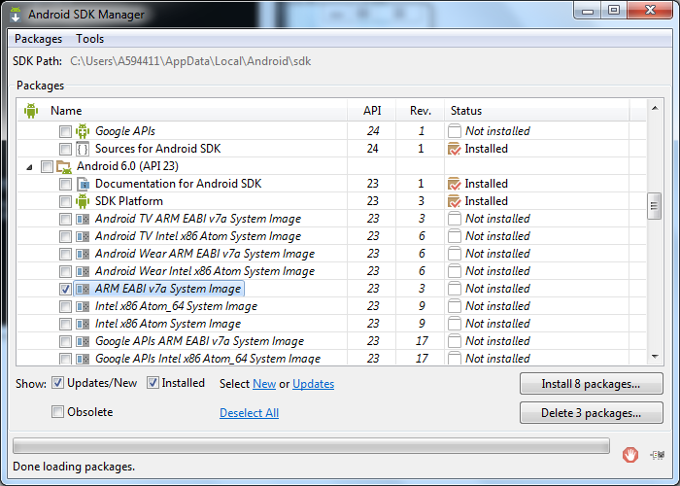

Once the desired APIs have been selected, click the button labelled Install *x* packages, where *x* resembles the number of packages selected for install.

Accept the Licence Agreement on the next screen and click Install. The agreement may be copied or printed for later reference.

When the installation has finished, a message “*Done loading packages*” will appear at the bottom of the window pane.

Close the Android SDK Manager in the usual way.

### Create Emulator

Open the AVD Manager in the root directory of the Android SDK.

Click Create.

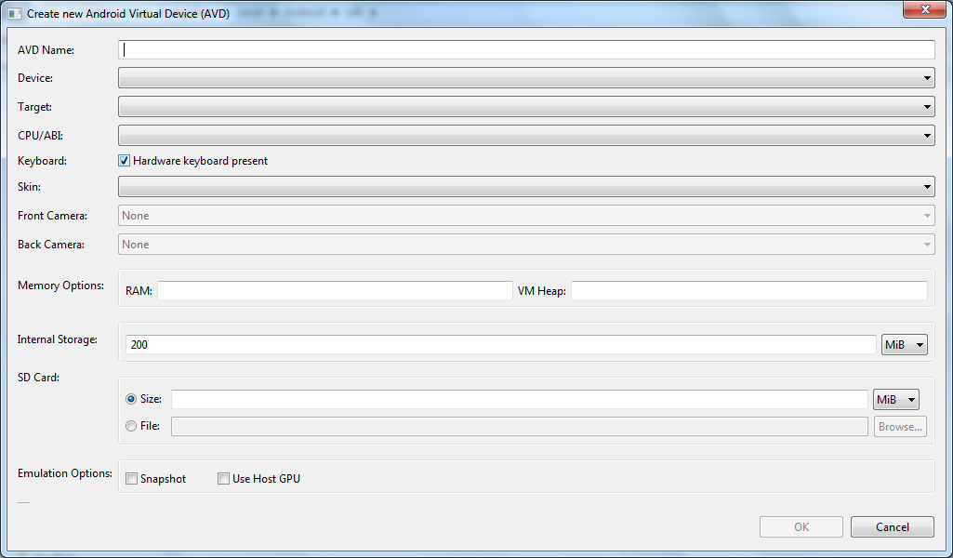

Compete the fields as shown:-

AVD Name: choose a name for the virtual device, e.g. Nexus 5

Device: select the appropriate device listing

Target: select the corresponding API target, e.g. API Level 22

CPU/ABI: this corresponds to the system image. Either leave as default or select the appropriate one.

Ensure that the checkbox against Hardware Keyboard Present is selected.

RAM: 1536

VP Heap: 32

Internal Storage: 800 MiB

Size: 100 MiB

Ensure that the checkbox against Use Host GPU is selected.

Click OK

# Install Ruby

Obtain the latest version of the Ruby installer from <http://rubyinstaller.org/downloads>.

At the time of writing this the version installed is: 2.2.5 (x64).

Open the installer in the downloaded location (Ruby 2.2.5 (x64)) and follow the prompts to install the standard environment.

On completion, ensure the environmental variable RUBY_HOME has been created and it is referenced correctly for the required instances in the environment path. Please refer to the **Environment Variables** section on how to do this.

# Install Cucumber

Pre-requisite:

Ruby needs to be present in the Environment Variables PATH.

Please ensure the steps to install Ruby have been followed before proceeding.

Open a Command Prompt.

Enter gem install cucumber.

The Command Prompt will return once Cucumber has installed.

To close the Command Prompt, type exit at the prompt.

# Install Appium

Obtain the latest version of Appium from <http://appium.io/>

The format of the download will be a .zip file which will contain the installer. Extract the contents of the folder to obtain the Appium installer file.

Open the installer and follow the prompts to install the standard Appium Server environment.

Once installed, open Appium Server from the Start menu.

Appium Server will need to be configured to monitor or ‘listen to’ communication between the mobile emulator / physical device and the ruby scripts against which it has been executed.

Open up Android settings by clicking on the  icon.

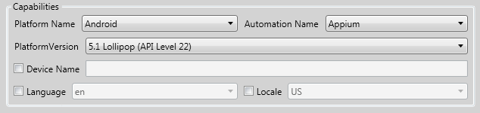

Ensure that the Capabilities pane of the Android Settings window is set to the following configuration:-

|  |  |
| --- | --- |
|  |  |
| Platform Name | Android |
| Automation Name | Appium |
| Platform Version | 5.1 Lollipop (API Level 22) |

Please note that the platform version will need to correspond to the API Level of the mobile device / emulator.

# Test Execution

Pre-requisites:

This section assumes that all other stages have been completed, including the configuration of all environment variables as detailed for reference in the section below.

It also assumes that a working Ruby script including at least one feature scenario is present for a test execution to be run.

Open Appium from the start bar, and click the  button to start the server.

Navigate to the root folder of the test project.

Ensure that the corresponding .apk file against which the test script is to be run resides at this root location.

Open a Command Prompt; from the Start menu search bar, enter cmd.exe and execute.

Enter the following command to spin up an emulator, where the emulator name denotes the name of the AVD device name.

emulator -avd {emulator name}

Once the emulator has been executed, open a Command Prompt at the root directory (Shift + left mouse key).

Enter the following command, where name denotes the name of the .apk file:-

cucumber PLATFORM=android APP_PATH={name}.apk

The emulator should now momentarily reset itself and proceed to load the test routine and execute in its entirety.

The command prompt should provide a detailed log of the executed steps as per the Feature file and associated step definitions in addition to a pass or fail status.

# Environmental Variables

To open the environmental variables window, navigate to System Properties:-

Start menu -> Computer -> System Properties

Click Advance system settings.

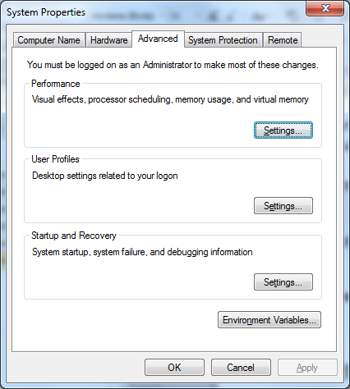

Click the button labelled Environment Variables.

Under the System variables pane, click New.

The table below provides the information required for the corresponding development kit. Please use this information as reference when completing the relative installations detailed in this guide.

Ensure that the **Variable value** is correct for each system path as these values may differ on the installation environment.

|  |  |  |
| --- | --- | --- |
| **DevKit / Installer** | **Variable name** | **Variable Value** |
| Java JDK | JAVA_HOME | C:\Program Files\Java\jdk1.8.0_60 |
| Android SDK | ANDROID_HOME | C:\_development\tools\Android\sdk |
| Ruby | RUBY_HOME | C:\_development\tools\Ruby22-x64 |

Click OK once the System Variable has been entered.

Select the Path variable in the list and click Edit. Append the system path relative to the installation stage currently in process.

|  |  |
| --- | --- |
| **DevKit / Installer** | **PATH** |
| Java JDK | %JAVA_HOME%\bin\; |
| Android SDK | %ANDROID_HOME%\tools\;  %ANDROID_HOME%\platform-tools\; |
| Ruby Installer | %RUBY_HOME%\bin\; |

Click OK once the System Variable has been entered.

Click OK on the Environment Variables properties window.

Click OK on the System Properties window.

Close the Control Panel in the usual way.